Learning analytics (0,5)
Along with technology improvements, every aspect of human's life is being transformed. We are witnessing huge digitalization everywhere. Huge amount of data is being collected. Learning is no exception [1]. Learners can achieve “anytime, anywhere any device” learning to satisfy their individual demands and consequently a lot of logs are being collected [2], [4], [5]. Siemens (2010) defines Learning Analytics as “the use of intelligent data, learner-produced data, and analysis models to discover information and social connections, and to predict and advise on learning.” [1]. In other words, we consider learning analytics: collection, measurement, analysis and reporting of data about learners for better understanding and enhancing learning efficiency. While students are taking virtual lessons in Yuan Ze University, logs of data are being taken and afterwards parsed and analyzed using different intelligent algorithms and then displayed in human readable format (usually graphs and tables). Results of learning analytics give better insight for teachers in student profile [6]. By creating a profile for each student and by using data of similar students, system can give feedback about lessons student took, suggest next steps in learning or predict learning progress.
Prediction algorithms (0,5)
Once enough student’s data is collected, system tries to extract important information from the data. Field of computer science that extracts important information from datasets is called machine learning. In machine learning, there have been developed different algorithms that uses different approaches in analyzing the data. Every algorithm is made of three parts: model, loss function, and optimizing method. In model, (not necessary finite) set solution is defined which is being searched of for the one that has the smallest loss using specified optimizing algorithm. Our goal is to predict the learning curve. We can imagine our problem as interpolation between points, in other words we are trying to find the function that approximates the points the best. The set of the functions we will be looking will be the model of the predicting algorithm. Loss function will be function that will rate how good the approximation is and as optimizing algorithm we will use gradient descent method. Algorithm that is defined with those three parts is known as regression. [7], [8]
Data collection via logs and log processing algorithms (1)
Currently our students have taken three different type of lessons: gamified, augmented reality and collaborative lessons. In each of this types there are different groups of learning exercises and each of these has a different type of logging. Logs are stored in a database as a single row with attributes to get information of student, date and time of log and JSON object which contains the characteristic info of the lesson action. On following images (img1, img2 and img3) are shown structure of characteristic JSON object for each of type of the logs.
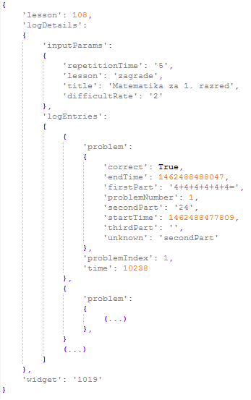
img 1 competitivie lesson log
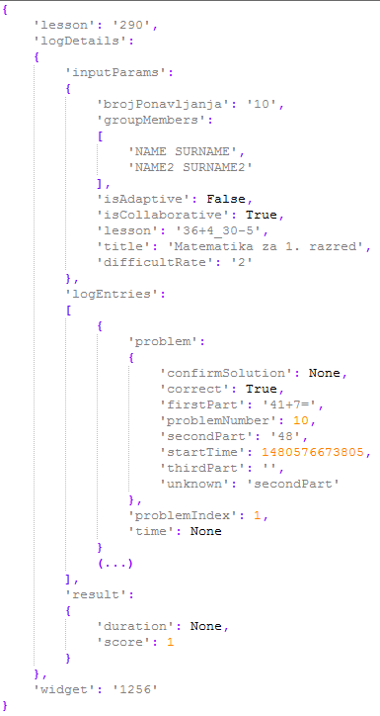
img 2 colaborative lesson log
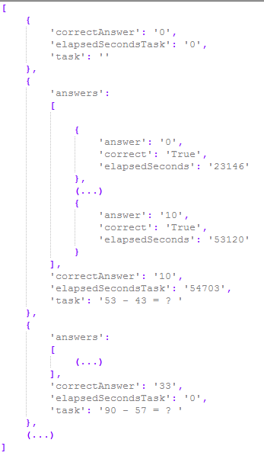
img 3 AR lesson log

As it is visible from images, information of whether student solved exercise correctly and thinking time is easily calculated from the object which are the main information used in rating students and lessons (more in next chapter).
Student learning success and task difficulty computation algorithms (1)
Calculating student success is not an easy task in case when there is no prior information of difficulties differences between lessons if all students didn’t take same set of lessons. Difficultness rate of the lessons could be statistically extracted from data if same students attempted to solve them (i.e. lessons that have been solved twice more than some other lessons are two times easier). Same thing can be said for extracting student success in lessons if all took same lessons. Also, if there was an information about difficulties differences between lessons it would be possible to calculate students’ success. Analogously, if there was an information about efficacy of students (so we could mathematically compare students’ efficacy) we could calculate lessons difficulties. We have recursive dependency:
$$S=f\left(L\right)$$
$$L=f\left(S\right)$$
S – Students’ success (vector)
L – Lessons’ difficulties (vector)
Student success is rated with a real number from [0, 1], where 1 means 100% success and 0 means 0% of success. Lesson difficulty is also rated with a real number from [0, 1] where 0 means 0% of (average) students successfully completed and 1 means 100% of (average) students successfully manage to complete. Information whether student at index i solved lesson j is stored inside a matrix at position T(i, j) with values:
$$T_{i,j}=T(i, j)=\left\{\begin{aligned}-1, & student i falied j lesson \\ 0, &student i {didn}^{'}t attempt lesson j \\ 1, &student i solved lesson j \\ \end{aligned}\right.$$
Accuracy and time of solving an exercise in a lesson j for student i is stored inside a matrix at position P(i, j) with a real number from [0, 1], where 1 is the best accuracy and time. P(i, j) is function of time and accuracy which differ from lesson to lesson. For P(i, j) we used
$$P_{i,j}=P\left(i, j\right)=1-\frac{\min\left(t_{max},\max\left(0, t-t_{min}+f*(n-1)\right)\right)}{t_{max}}$$
where
$t-time for solving the exercise$,
$$t_{min}-expected time to solve the exercise,$$
$$t_{max}-expected maximum time to solve the exercise,$$
$$f-penalty factor,$$
$$n-number of attempts$$
because it has the following properties:
- P(i, j) = 1 if it took student less than t_{min} time to solve the exercise and they solved it in first attempt.
- P(i, j) = 0 if it took student more than t_{max} time to solve the exercise.
- P(i^{(k)}, j^{(k)}) > P(i^{(l)}, j^{(l)}) if student k had less attempts then student l and same time as student the student l.
t_{min},t_{max} and f are lesson specific and should be wisely chosen (i.e. t_{min} could be time that is higher than 60% of students’ time and t_{max} is two times t_{min} , while f equals 2 seconds).
That is everything needed for state the recursive formula for student’s success S and lesson’s difficulty L:
$$O_{i}=\frac{\sum_{j=1}^{m}{\left(f_{s}\left(T_{i,j}\right)f_{t}\left(T_{i,j}\right){f_{p}\left(L_{i,j}\right)}^{T_{i,j}}* P_{i,j}\right)}}{\sum_{j=1}^{m}{\left(f_{s}\left(T_{i,j}\right){f_{p}\left(L_{i,j}\right)}^{T_{i,j}}* P_{i,j}\right)}}$$
$$L_{j}=\frac{\sum_{i=1}^{n}{\left(f_{s}\left(T_{i,j}\right)f_{t}\left(T_{i,j}\right){f_{p}\left(O_{i}\right)}^{T_{i,j}}* P_{i,j}\right)}}{\sum_{i=1}^{n}{\left(f_{s}\left(T_{i,j}\right){f_{p}\left(O_{i}\right)}^{T_{i,j}}* P_{i,j}\right)}}$$
where
m is number of lessons (size of L),
n is number of students (size of S),
$$f_{s}\left(x\right)=x^{2}$$
is solving function that returns 1 if student attempted to solve the lesson,
$$f_{t}\left(x\right)=\frac{x+1}{2}$$
which is function that returns 1 if student solved correctly and 0 if they didn’t, and
$$f_{p}\left(x\right)=k^{1-2x}$$
is projection function that has properties:
- $f{\left(0\right)}^{T_{i,j}}$ = k, (student i gets k points for solving hardest exercise j, but loses $\frac{1}{k}$ points for failing)
- $f{\left(0.5\right)}^{T_{i,j}}$= 1, (student i gets 1 point for solving average exercise j, but loses 1 for failing)
- $f{\left(1\right)}^{T_{i,j}}$= $\frac{1}{k}$, (student i gets $\frac{1}{k}$ point for solving easiest exercise j, but loses k for failing)
To find a solution for this problem we used iterative approach by first fixing S and calculating O, then fixing O and calculating S, and repeat it until S and O converge. Experimentally we showed that this problem will always converge but not always to same values, they depend on initial values of O and S what was expected (i.e. if all students solved all lessons, it could mean all students know the lessons or lessons are too easy, or even both). To solve non-deterministic problem, we will set initial values of S to 1 and of O to 0.5 (it’s better to say that students and mistake than to say that opposite case).

Prediction algorithms (1)
Once there are periodical data that give information of student’s success one can assume that it can be used for future prediction of the same data. The assumption is correct only when difficulties of lessons have been fixed. So, the final move that is expected is to first preprocess data and calculate lessons’ difficulties, fix them and calculate success of students. Machine learning algorithm for drawing a function that best approximates given dots is called regression. Model of the algorithm was family of logarithmic functions. Loss function of the algorithm was were square loss (L2 loss), while was gradient descent method.

[1] http://ifets.info/journals/15_3/4.pdf

[2] http://ieeexplore.ieee.org/document/6982089/

Big Log Analysis for E-Learning Ecosystem

[3] http://www.jstor.org/stable/pdf/jeductechsoci.15.3.58.pdf

[4] L. Breslow, D. E. Pritchard, J. DeBoer, G. S. Stump, A. D. Ho, and D. T. Seaton. " Studying learning in the worldwide classroom: Research into edXs first MOOC, " Research & Practice in Assessment, vol.8, 2013, pp: 13-25.
[5] T. KARSENTI, " What the research says, " International Journal of Technologies in Higher Education, vol.10(2), 2013, pp. 23-37

[6] http://ieeexplore.ieee.org/stamp/stamp.jsp?arnumber=7335629
Open Student Models of Core Competencies
at the Curriculum Level: Using Learning
Analytics for Student Reflection
[7] Introduction to Machine Learning - Ethem Alpaydin
[8] STRUCE_Bishop_-_Pattern_Recognition_and_Machine_Learning

http://www.aclweb.org/anthology/P12-1003
http://ac.els-cdn.com/S1877042814021338/1-s2.0-S1877042814021338-main.pdf?_tid=5388cb4e-44a5-11e7-9fa7-00000aacb360&acdnat=1496086432_7856d0e3edad5bbf449f8bc6c9011c76

